EU AI Act: A Beginner’s Guide
Reading time: 15 minutes
What is the EU AI Act?
The EU AI Act is a new law that controls how artificial intelligence (AI) can be used in Europe. Think of it as a rulebook that makes sure AI is safe and fair for everyone. It’s the world’s first major law about AI. It was published on July 12, 2024 and entered into force on August 1, 2024, with different rules taking effect on a phased timeline.

Why Does This Law Exist?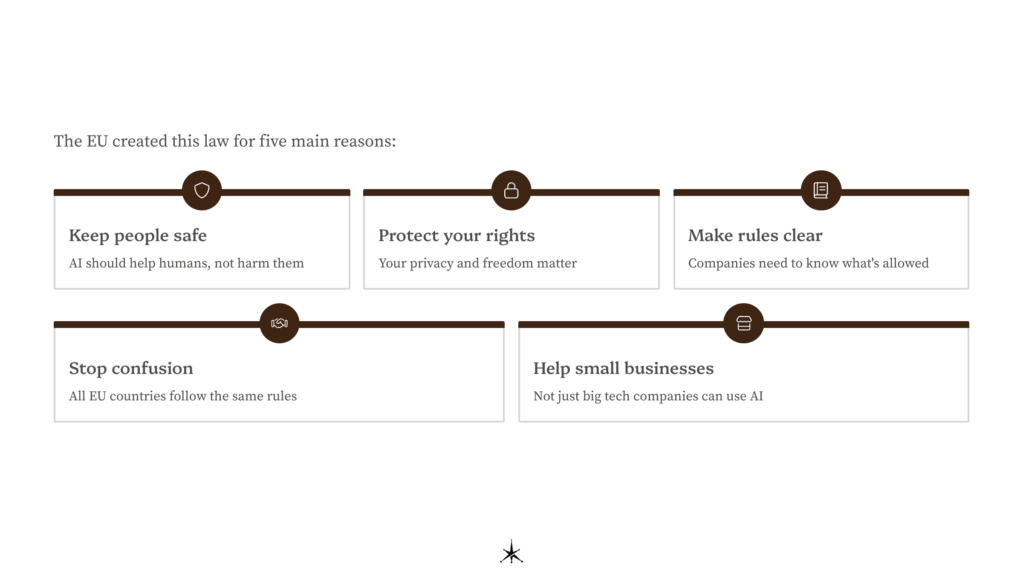
The EU created this law for five main reasons:
- Keep people safe – AI should help humans, not harm them
- Protect your rights – Your privacy and freedom matter
- Make rules clear – Companies need to know what’s allowed
- Stop confusion – All EU countries follow the same rules
- Help small businesses – Not just big tech companies can use AI
Think of it like traffic laws – we need rules so everyone stays safe and knows what to do.

Who Must Follow These Rules?
The law applies to different groups:
Providers
- Companies that make AI systems
- Like a toy manufacturer making a robot toy
Deployers
- Organizations using AI in their work
- Like a school using AI to grade tests
Importers
- Businesses bringing AI from other countries into Europe
- Like someone importing smartphones with AI features
Distributors
- Stores or websites selling AI products
- Like an electronics shop
You and Me
- Regular people are affected when AI is used on us
- But we don’t have to follow special rules

The Four Risk Levels (Like a Safety Scale)
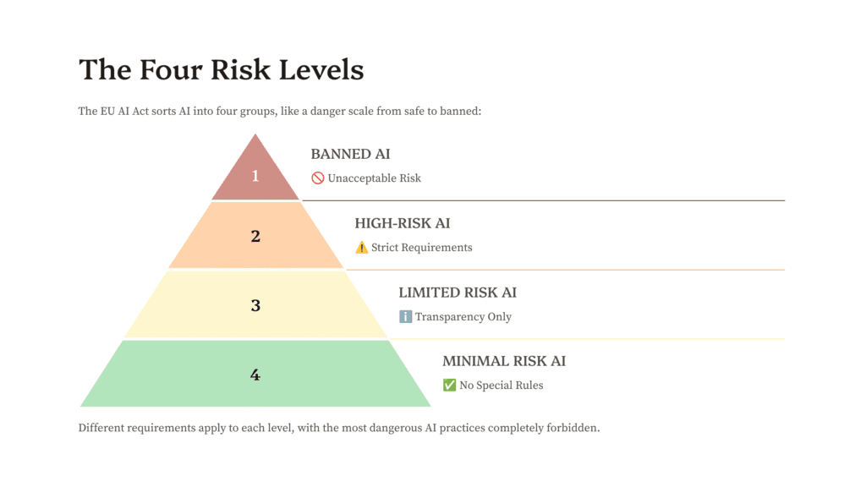
The EU AI Act sorts AI into four groups, like a danger scale from safe to banned:
1. BANNED AI (Unacceptable Risk)
These are completely forbidden
What’s banned:
- Mind tricks – AI that secretly controls what you do
- Social scores – Rating people like in a video game
- Face scanning in public – Real-time face scanning in public by law enforcement is restricted, with specific exceptions for serious crimes and imminent threats.
- Emotion readers at work/school – Emotion detection at work or school based on biometric data (like facial expressions or voice patterns) is banned, with exceptions for medical or safety reasons.
- Unfair profiling – Judging if someone might commit crimes based on their personality
When banned: February 2, 2025
2. HIGH-RISK AI
These need lots of checks and rules
Examples:
- AI that helps hire people for jobs
- AI that grades students
- AI that decides who gets a loan
- AI used by police
- AI in medical devices
- AI controlling traffic lights
What they must do:
- Pass safety tests
- Have a “CE” mark (like a safety sticker)
- Register in an EU database
- Let humans override decisions
- Keep records of what they do
- Be transparent about how they work
3. LIMITED RISK AI
These just need to be honest
Examples:
- Chatbots (must say they’re not human)
- Deepfakes (must say they’re fake)
- AI creating images or videos
Main rule: Tell people when they’re dealing with AI
4. MINIMAL RISK AI
Most AI falls here – no special rules
Examples:
- Spam filters
- Video game AI
- Recommendation systems (like “you might also like…”)

Special Rules for Super-Smart AI (GPAI)
Some AI systems are really powerful and can do many things (like ChatGPT). These are called “General-Purpose AI” or GPAI.
All GPAI must:
- Keep technical records
- Respect copyright
- Say what data they trained on
- Help other companies understand them
Extra-powerful GPAI must also:
- Test for dangers
- Report serious problems fast
- Have strong security
- Check for risks to society

What Companies Must Do
For High-Risk AI:
- Risk Management
  - Find dangers
  - Fix problems
  - Keep checking
- Good Data
  - Use fair information
  - Remove errors
  - Represent everyone
- Clear Instructions
  - Easy-to-understand manual
  - List of risks
  - How to use safely
- Human Control
  - People can stop the AI
  - People understand what AI is doing
  - No blind trust in AI
- Keep Records
  - Save what AI does
  - Store for 6+ months
  - Help investigations

Your Rights as a Person Under the EU AI Act
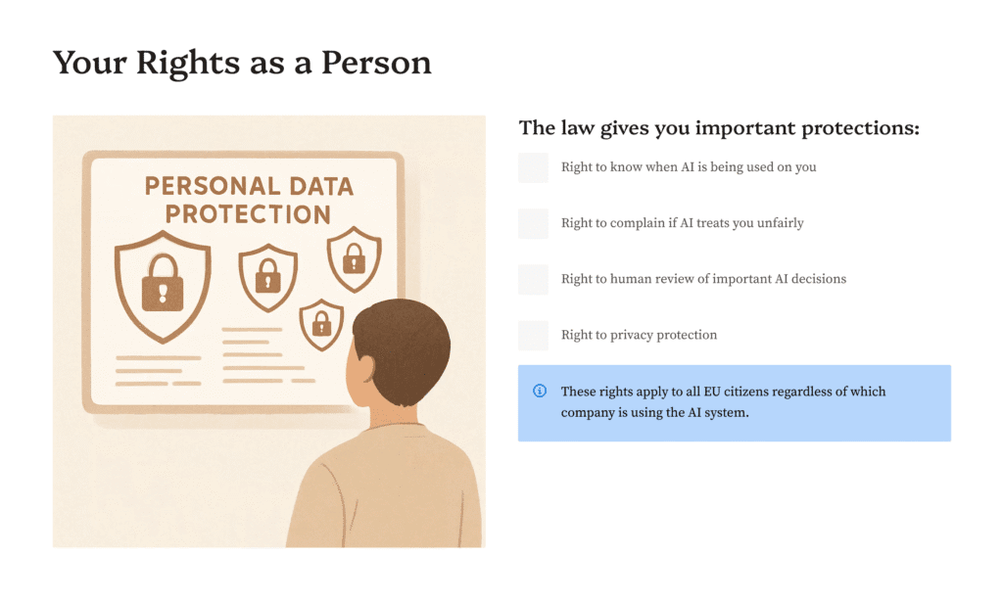
The law gives you important protections when organizations use AI systems that affect you:
Right to Know (Transparency)
AI systems must identify themselves and their artificial nature:
- Chatbots must say they’re AI, not human
- Deepfakes and AI content must be clearly labeled
- Emotion recognition systems must inform you they’re active
- Information must be clear and accessible, including for people with disabilities
Right to Complain (Remedy)
You can challenge unfair AI treatment:
- File complaints with your national market surveillance authority
- Existing rights for consumer and data protection still apply
- Authorities must investigate your concerns as part of monitoring
- Whistleblowers get special protection when reporting violations
Right to Human Review
Real people must oversee important AI decisions:
- Qualified humans can monitor and override AI systems
- Clear explanations required for decisions affecting your rights
- Critical systems need verification by two trained people
- Stop mechanisms must exist to interrupt AI operations
Right to Privacy Protection
Your data stays protected when used by AI:
- GDPR still applies with all current privacy rights
- Banned practices include mass surveillance and exploiting vulnerabilities
- Data minimization required – AI can only use necessary data
- Special protections for sensitive information like health or biometric data

The Punishment System (Fines)
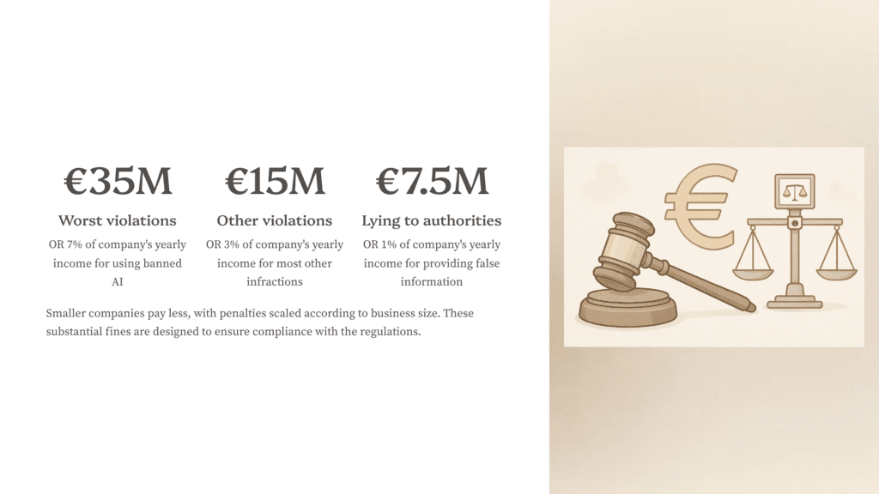
Breaking the rules costs money:
Worst violations (banned AI):
- Up to €35 million
- OR 7% of company’s yearly income
Other violations:
- Up to €15 million
- OR 3% of company’s yearly income
Lying to authorities:
- Up to €7.5 million
- OR 1% of company’s yearly income
Smaller companies pay less

Important Dates to Remember
- August 2, 2024 – Law officially started
- February 2, 2025 – Banned AI rules begin
- May 2, 2025 – Industry should have guidelines ready
- August 2, 2025 – Rules for super-smart AI begin
- August 2, 2026 – Most other rules begin
- August 2, 2027 – Rules for AI in products begin

Who’s In Charge?
EU Level:
- AI Office – Main AI police for Europe
- AI Board – Representatives from each country
- Expert Panel – Scientists who give advice
Your Country:
- Each country picks its own AI authorities
- They check companies follow rules
- They help with complaints

Innovation Support
The law isn’t just about stopping bad AI. It also helps good AI grow:
AI Sandboxes
- Safe spaces to test new AI
- Government supervision
- Helps small companies
- Must exist by August 2026
Real-World Testing
- Can test AI in real situations
- Need permission first
- Must protect people’s data
- Requires consent (usually)

Why This Matters to You
Even if you don’t work with AI:
- You’ll interact with AI – It’s everywhere
- Your rights are protected – The law watches out for you
- AI will be more trustworthy – Bad AI is banned
- You’ll know when it’s AI – No more tricks
- Humans stay in control – People make final decisions

Simple Summary
The EU AI Act is like a safety manual for AI. It:
- Bans dangerous AI
- Controls risky AI
- Makes AI be honest
- Protects your rights
- Helps good AI develop
- Punishes rule-breakers
Most importantly: AI should help humans, not replace or harm them.
So important, I’ll say it again: AI should help humans, not replace or harm them.

